16306 TPA 1221-03 February 2022 Social Media posts
HealthSelectShoppERS

Share text: As a HealthSelectSM plan participant, you may be eligible to earn HealthSelectShoppERSSM rewards in a TexFlexSM FSA. How? Shop for and choose high-quality, lower-cost options for certain medical services or procedures, including ultrasounds, CT scans and MRIs.

[Link to: https://healthselect.bcbstx.com/content/medical-benefits/healthselectshoppers]

Health Assessment

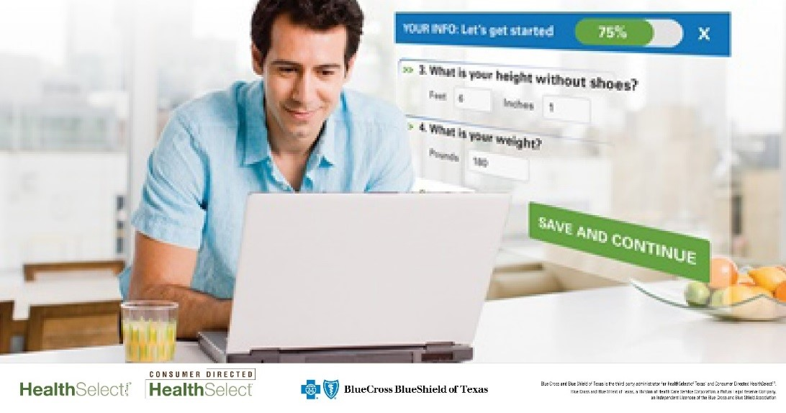

Share text: Reward yourself for your healthy habits. You can earn 2,500 Blue PointsSM every six months for completing your Health Assessment. You can spend your Blue Points online for a variety of items, including health and fitness gear, housewares and electronics.

[link to: https://healthselect.bcbstx.com/content/health-and-wellness-incentives/health-assessment]

Fitness Program
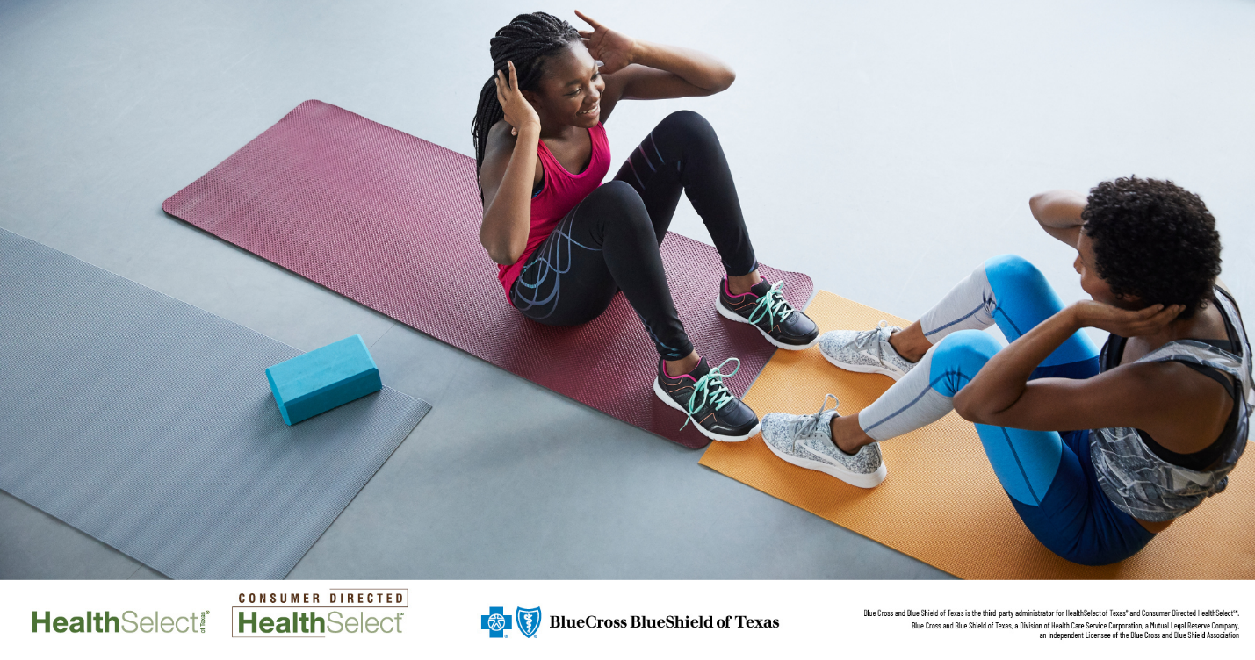
Share text: In February, get fit and save. There is no enrollment fee for HealthSelectSM participants who join the Fitness Program. That means you have plenty of options for improving your health during American Heart Month. Use code FEBFIT22.

[Link to: https://healthselect.bcbstx.com/content/health-and-wellness-incentives/fitness-program]
Well onTarget Challenge

Share text: Personal Challenges in Well onTarget® are a great way to jumpstart your health and wellness goals. This month, challenge yourself to perform An Act of Kindness each day for seven days. Choose kindness and take a moment to compliment someone in your life.

[Link to: https://healthselect.bcbstx.com/content/health-and-wellness-incentives/portal]

Well onTarget Coaching

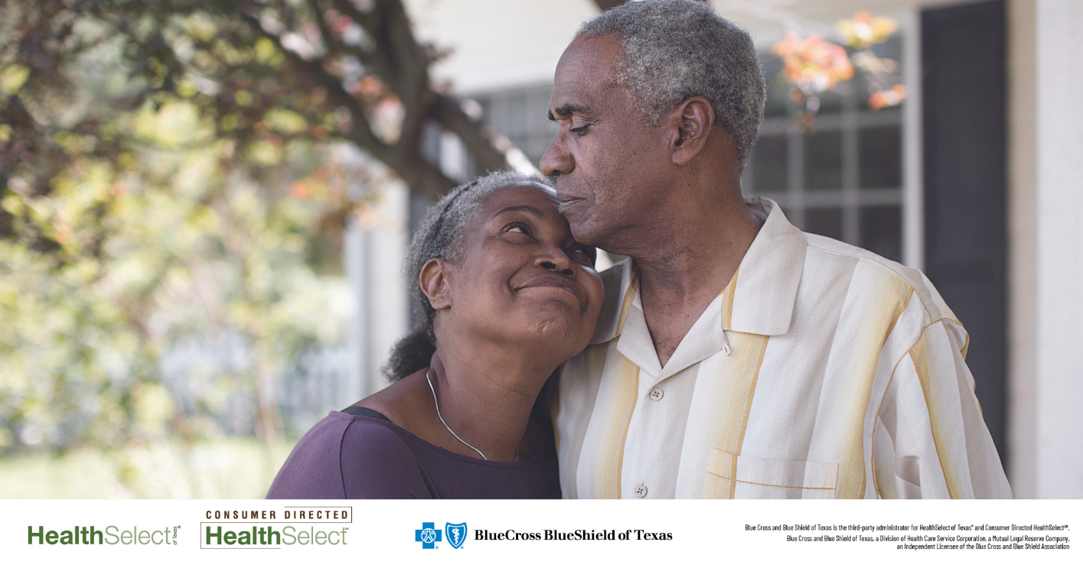

Share text: Well onTarget® coaches help you set and achieve your personal health and wellness goals. The coaching team is made up of health experts, including dietitians, nurses and personal trainers, who will work one-on-one with you to learn your lifestyle needs.

[Link to: https://healthselect.bcbstx.com/content/health-and-wellness-incentives/tools-coaching]

