June Social Media Posts
Social Media Post #1:
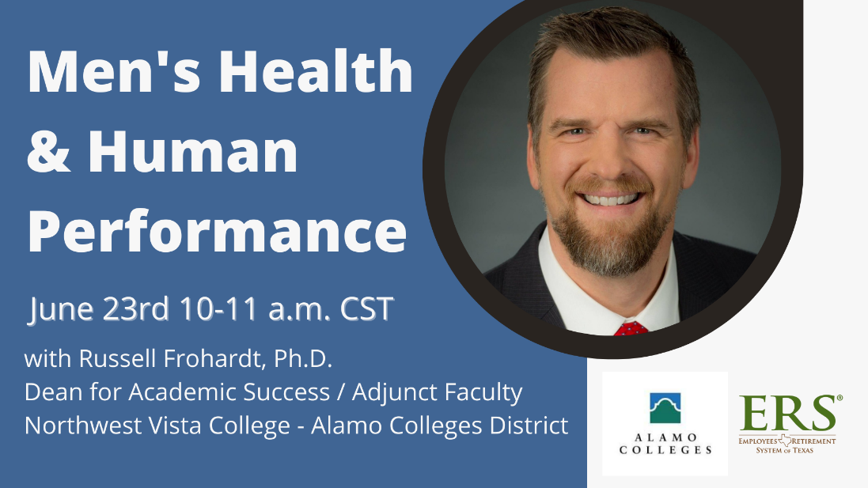
Insert Text: If you are a man, or you have a father, spouse, son, uncle, or other men in your life who you care about, you will want to attend this webinar! Registration Link: https://alamo.zoom.us/webinar/register/WN_xo77VGmkQiiXK5EoVHAeQg

Social Media Post #2: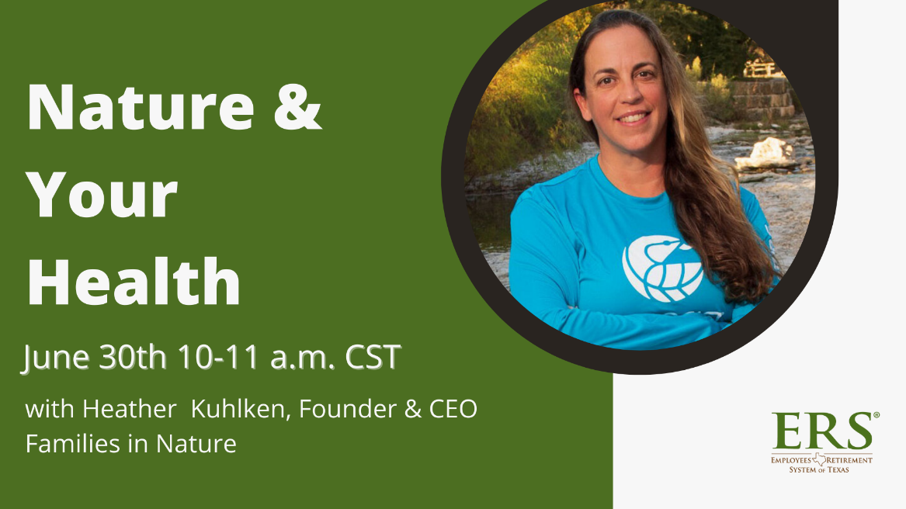

Insert Text: Join us for a new webinar featuring Heather Kuhlken, a biologist and outdoor educator who inspires individuals and families to fall in love with nature and reap the benefits, ranging from better health to more resilient brains and stronger family connections. Registration link: https://attendee.gotowebinar.com/register/3117878948952005648

