March 2022 Social Media posts

Healthy Lifestyle Programs: Wondr Health & Real Appeal

Share text: Achieving better health for the long term is more than a diet here and a workout there. It takes a lifestyle change that starts with small steps. HealthSelect’s no-cost-to-you weight management programs are LIFESTYLE management programs that meet you were you are and take you where you want to be. [Direct link to YouTube Video: https://www.youtube.com/watch?v=UGMOfjSleUs]

Nutrition Webinars with Lindsey Menge, MS, RD, LD

Share text: It’s National Nutrition Month! Join in to learn how you can improve your nutrition all year with Lindsey Menge, MS, RD, LD through a cooking demonstration, or one of two webinars: Intermittent Fasting Explained or Eat More Plants! Learn more and register through the ERS Wellness Events Calendar: https://ers.texas.gov/Event-Calendars/Wellness-Events

Benefits and wellness apps

Share text: Your health and wellness benefits are at your fingertips! As a HealthSelectSM plan participant, you have access to mobile apps that can help you find providers, estimate health care spending and even get in a quick workout.

Weight management
Share text: With WondrTM or Real Appeal®, you can get the support you need to manage your weight. Both programs are available at no additional cost for eligible HealthSelectSM participants.

[Link to: https://healthselect.bcbstx.com/content/health-and-wellness-incentives/weight-management-programs]

Well onTarget Challenge

Share text: Personal Challenges in Well onTarget® are a great way to jumpstart your health and wellness goals. This month, join the Move More, Sit Less challenge. Set up a reminder every hour to get up and take a two-minute walk.

[Link to: https://healthselect.bcbstx.com/content/health-and-wellness-incentives/portal]

Fitness Connect Community

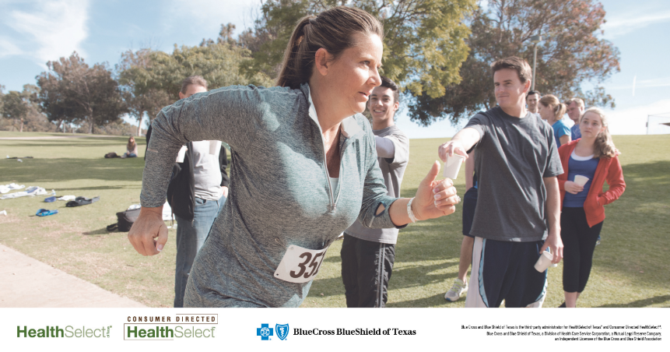

Share text: You’re invited to join the Fitness Connect Community! The monthly sessions, held at 10 a.m. CT the second Tuesday of each month, feature discussions with wellness consultants to help you get fit and stay healthy throughout the year.

[Link to Cvent registration site: https://cvent.me/P0AOoD]

