August 2022 Social Media Posts

- If you have money goals, you won't want to miss these wellness opportunities featuring topics like Eating Well on a Budget, Self-Leadership & Your Financial Journey! Check out the ERS Wellness Events calendar for dates and registration details: https://ers.texas.gov/Event-Calendars/Wellness-Events

- Are you eligible for the federal Public Service Loan Forgiveness Program? Learn more about PSLF from the experts at Trellis during this 20-minute episode of the ERS Walk & Talk Podcast!
Direct link to the episode: https://www.buzzsprout.com/1566635/11031841
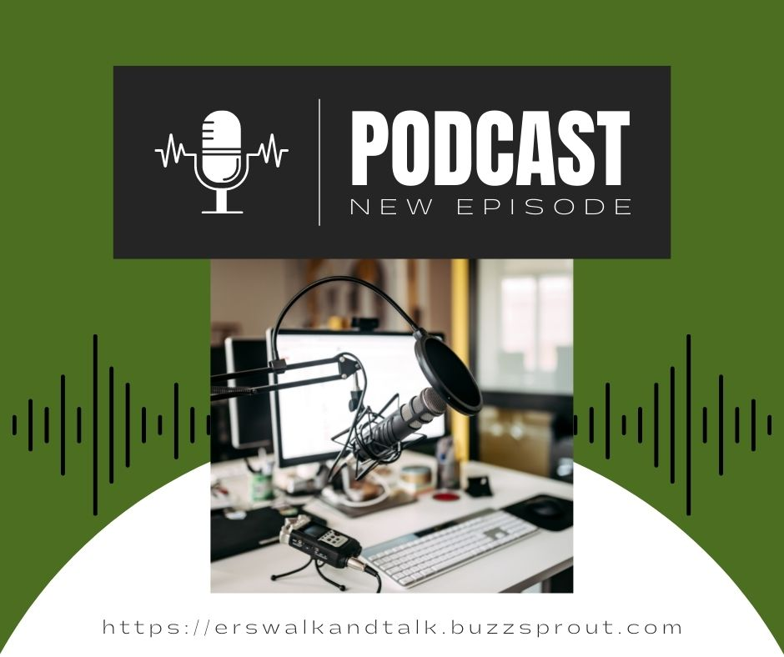

- Are you eligible for the federal Public Service Loan Forgiveness Program? Find out from the experts at Trellis and register for an upcoming webinar to get live answers to your questions. Can’t attend a webinar, Trellis has resources for you at this website.

www.trelliscompany.org/pslf-limited-waiver/

