September Social Media Posts

WEBINAR PROMOTION:
SHARE TEXT: For full details and the registration link, visit the ERS Wellness Events Calendar: https://ers.texas.gov/Event-Calendars/Wellness-Events
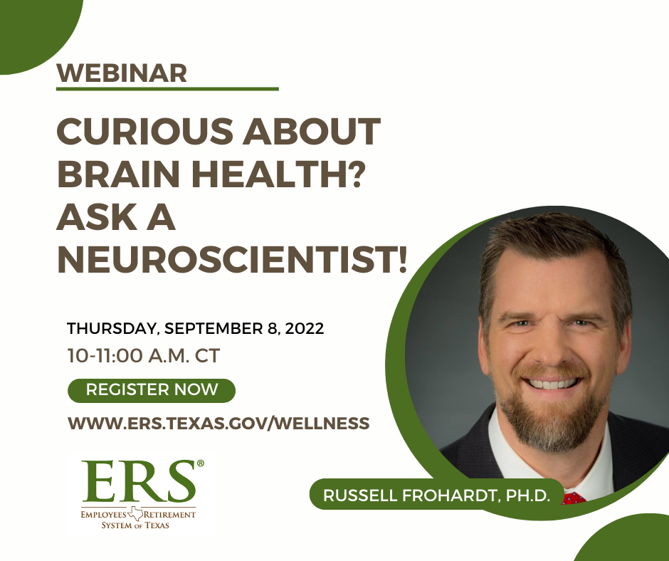

SHARE TEXT: For full details and the registration link, visit the ERS Wellness Events Calendar: https://ers.texas.gov/Event-Calendars/Wellness-Events
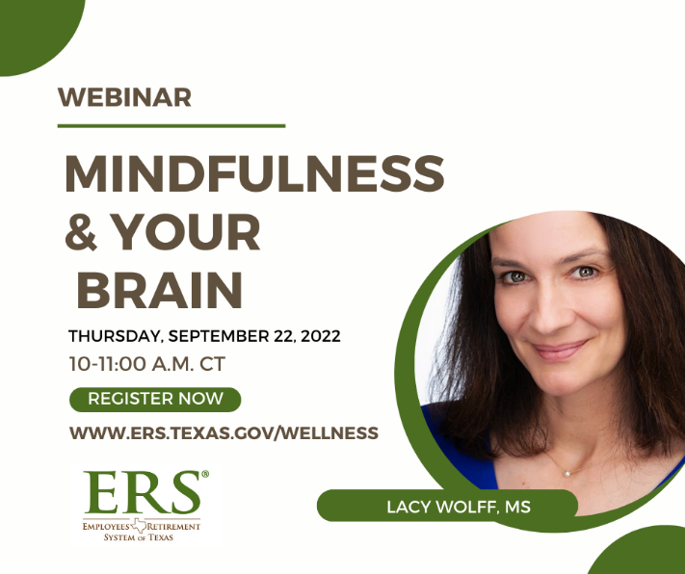

Mental health Virtual Visits

Share text: If you are experiencing emotional challenges, you have support. HealthSelectSM coverage includes access to no-cost mental health Virtual Visits for those enrolled in HealthSelect of Texas®, HealthSelectSM Out-of-State and HealthSelectSM Secondary. Consumer Direct HealthSelectSM participants pay 20% of the cost of a mental health Virtual Visit after meeting the annual deductible.

[Link to Virtual Visits page: https://healthselect.bcbstx.com/content/medical-benefits/virtual-visits#Mental%20Health%20Virtual%20Visits]

